- Purpose

The purpose of this procedure is to define the process required to lock out the Brine Tank #2 at the Manufacturing facility.
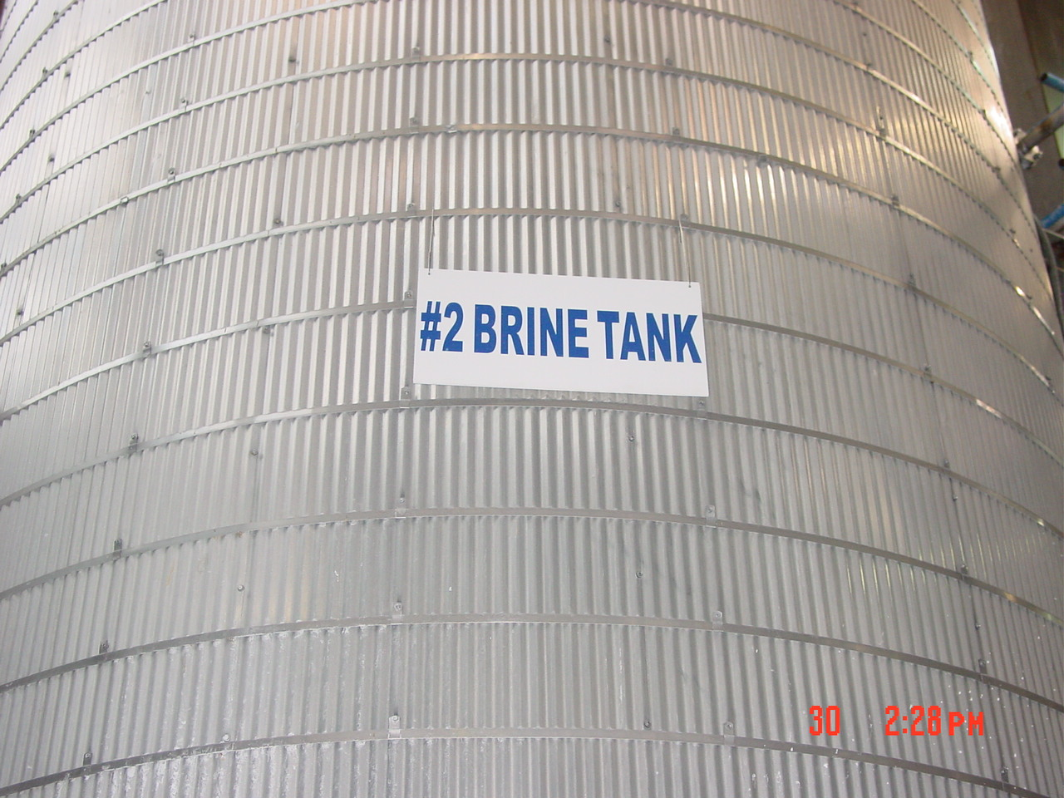

- Scope

This procedure applies to all maintenance workers.

- Responsibility

Maintenance and Production

- Safety Considerations

Safety glasses and appropriate safety apparel is to be worn at all times.

Safety is a condition of employment. Employees are not authorized to work in an unsafe manner and are prohibited from harming the environment of the facility or community.

- Materials/Equipment

- Lock
- Tag
- Lock out device

- Procedure

The proper process to lockout #2 Brine Storage Tank for confined space entry is as follows:

- Notify all affected employees that the tank is being taken out of production.
- Lock out both #2 Brine Tank Inlet Valves located in the Filter Press Room with the appropriate lock out tag out multi-locking device(s) (valves are indicated as
“Inlet Valve(s) Brine Storage Tank #2”)

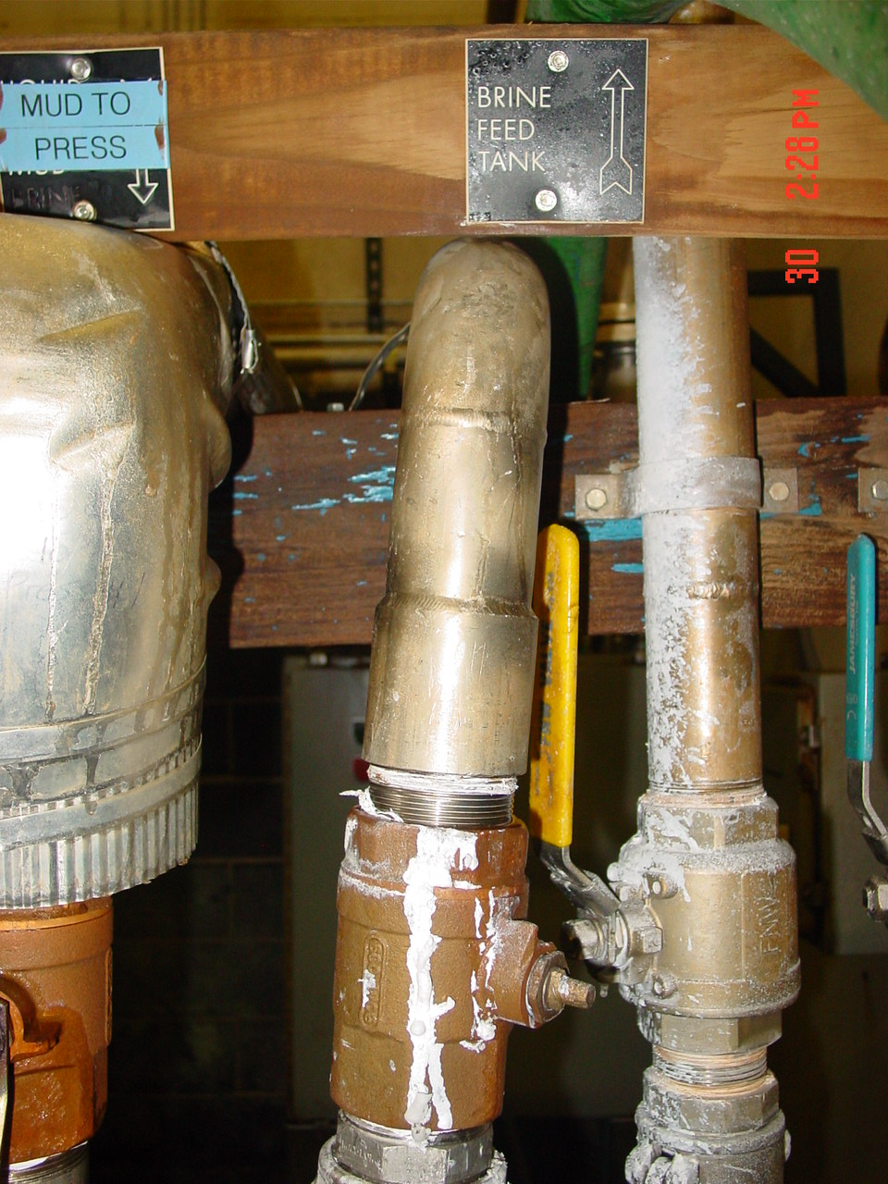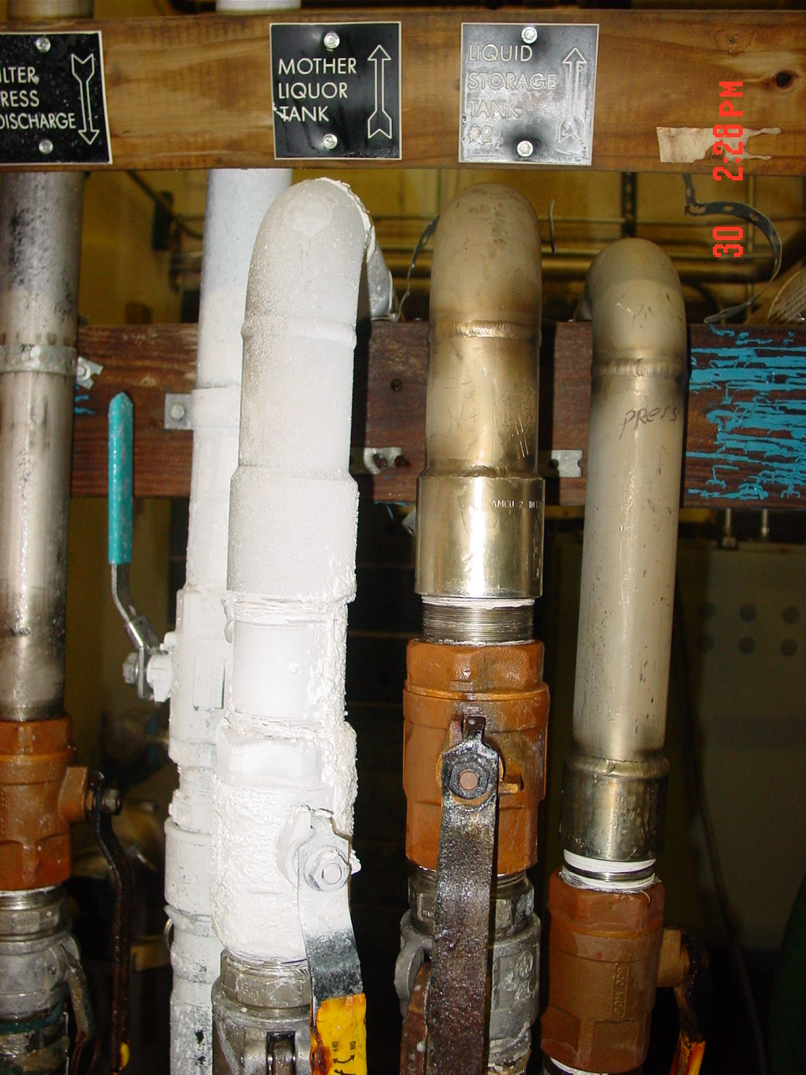
- ID tag(s) with name, date and time
- Test valve(s) to make sure they are not operational
- Drain #2 Brine Tank and confirm visually that the brine is below the access door.
- Once tank is drained to the appropriate level disconnect all hoses on the outlet side(s) of the tank.

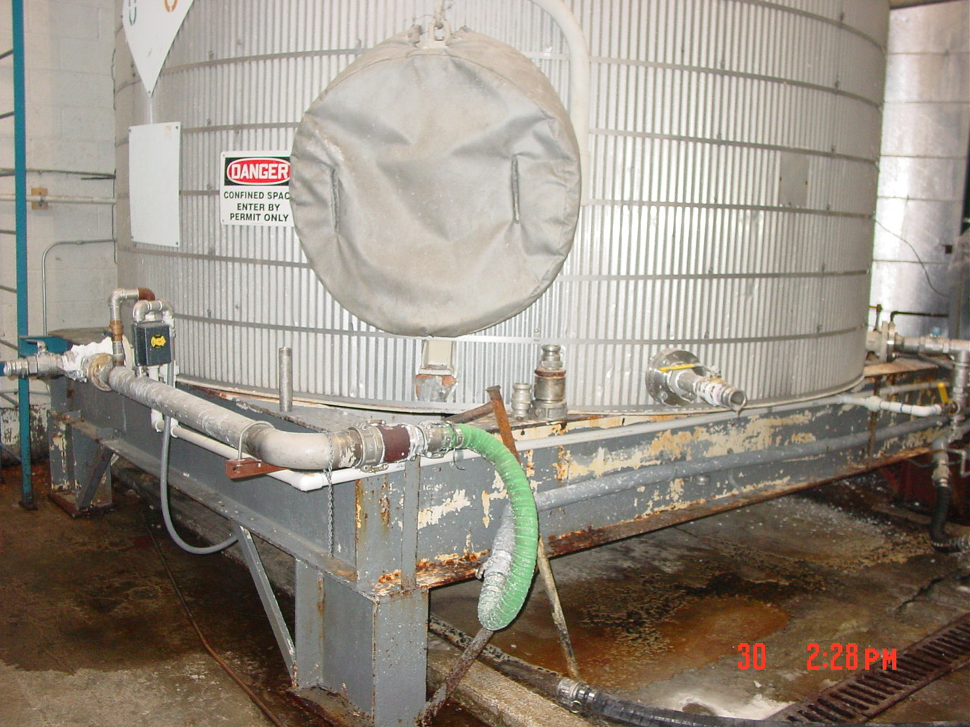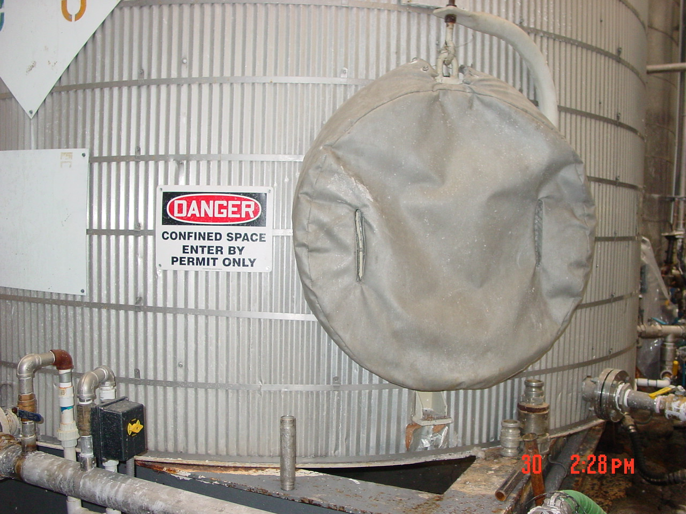

- Remove all hardware connecting access door to tank and remove gasket.
- Fill out confined space entry form associated with procedure (QA-HLTH-CSE) with all signatures before entering tank.

Before a Confined Space Entry Permit can be signed the following conditions have to be met;

- All Lock out(s) have to be performed, all electrically and mechanically driven equipment like agitators , pumps, valves have to be locked out, tagged and tried ( to make sure that nothing can start)

- All material supply lines have to be locked, tagged and tried, like acid, MgO, water, brine, steam, etc.

- The confined Space has to be properly ventilated to make sure that oxygen level is adequate. When the confined space has several opening besides the one entry egress no oxygen level measurement is necessary after ventilation.

- The air temperature in the Confined space has to be ambient or no higher than 90 degrees Fahrenheit ( 29 degrees Celsius)

- The liquid at the bottom of the confined space has to be tested for pH, has to be higher than 6 lower than 9.

- In case of the crystallizers air samples have to be taken to assure the proper air mixture for breathing. ( Oxygen concentration between 19.5-23.5 percent)

When all conditions from above are met and verified by the Entry Supervisor, the Confined Space entry form will be signed by the Entry Supervisor and one copy posted at the work site. The Confined Space Entry Form will be filled out in duplicate.
Once the entry was performed and the job completed the entry form will be removed

Proper procedure to return equipment to operation:

- Make sure all work is complete and all tools and maintenance equipment has been removed from the machine.
- Place access door back on tank and secure. (gasket should be replaced before placing access door on tank)
- Remove lock out tag out devices from #2 Brine Feed tank ball valve
- Remove lock out tag out devices from #1 Brine Feed tank ball valve
- Return all lock out devices and equipment to the production cabinet
- Ensure all equipment is operating properly and available to be returned to service.
- Turn in all appropriate confined space entry paperwork to the safety office.

- Reference Documents

N/A

- Change Information

Document review- updated format using new template and numbering system.

